Lecture 07

* We learnt about different types of data source e.g. sql, no-sql, ms azure and many more
* Getting data from web page like… data, page source code, tables etc.
* 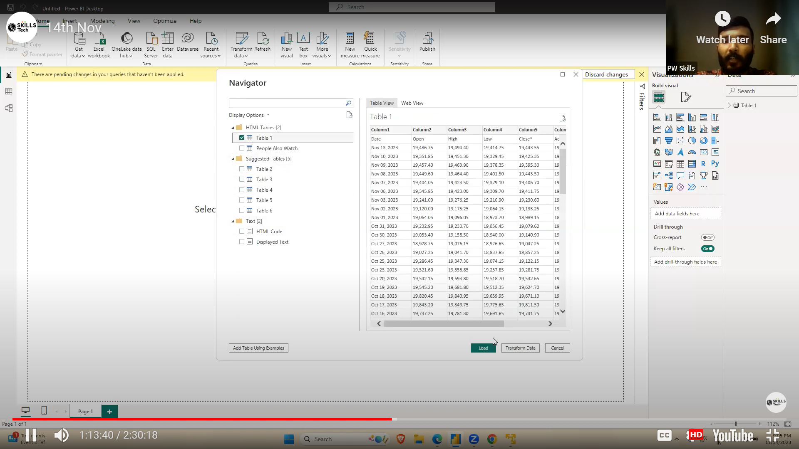
* 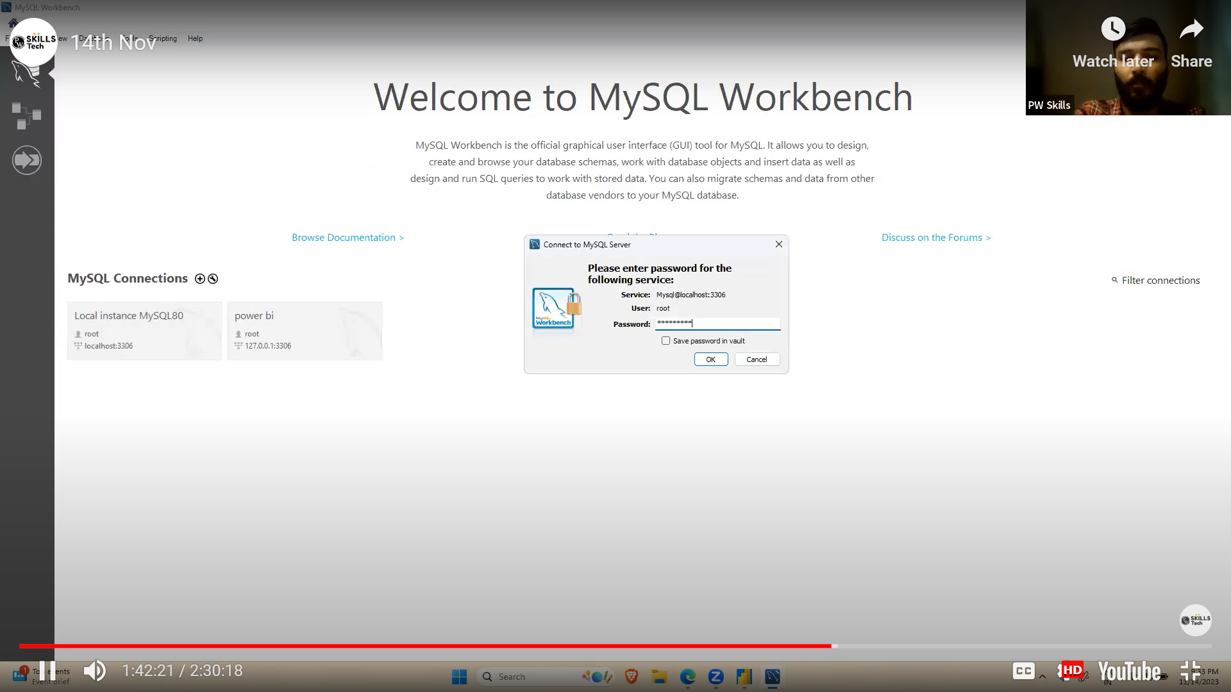
* 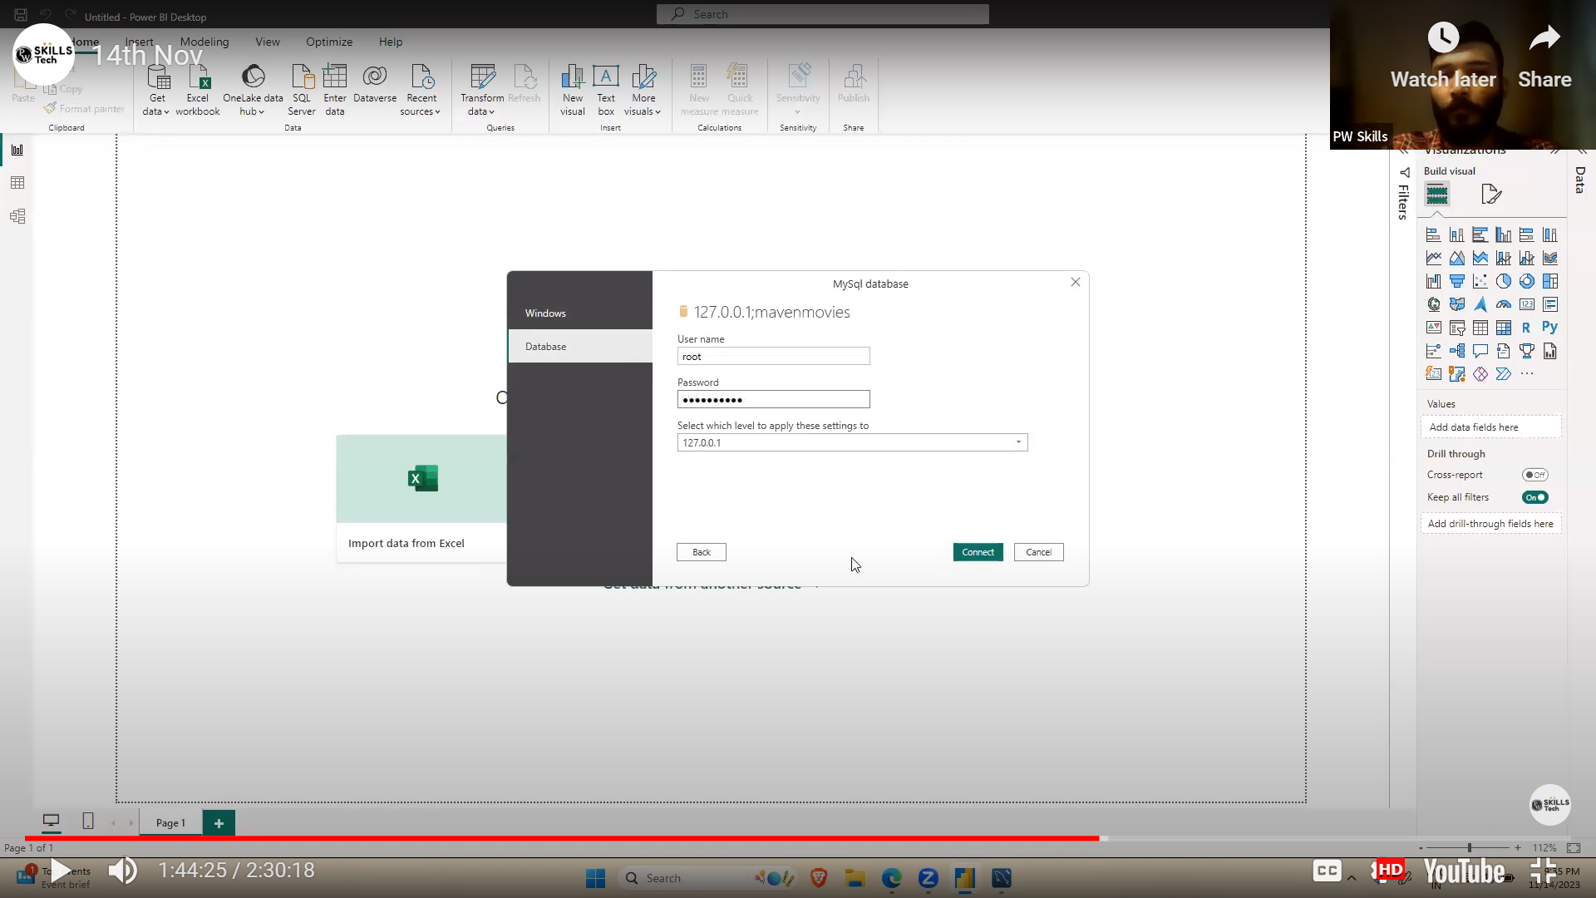
* 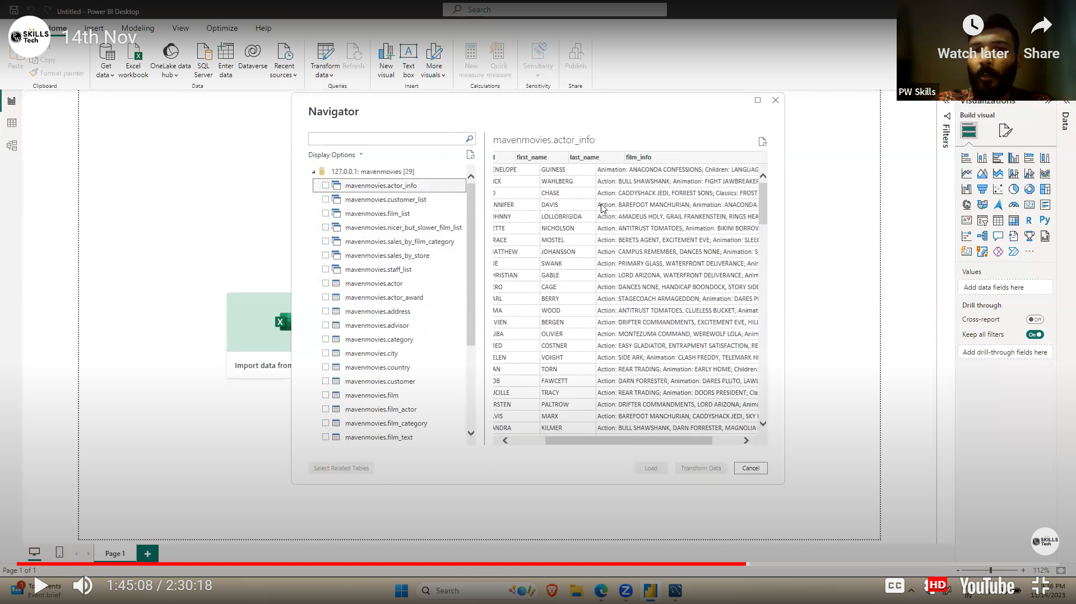
* 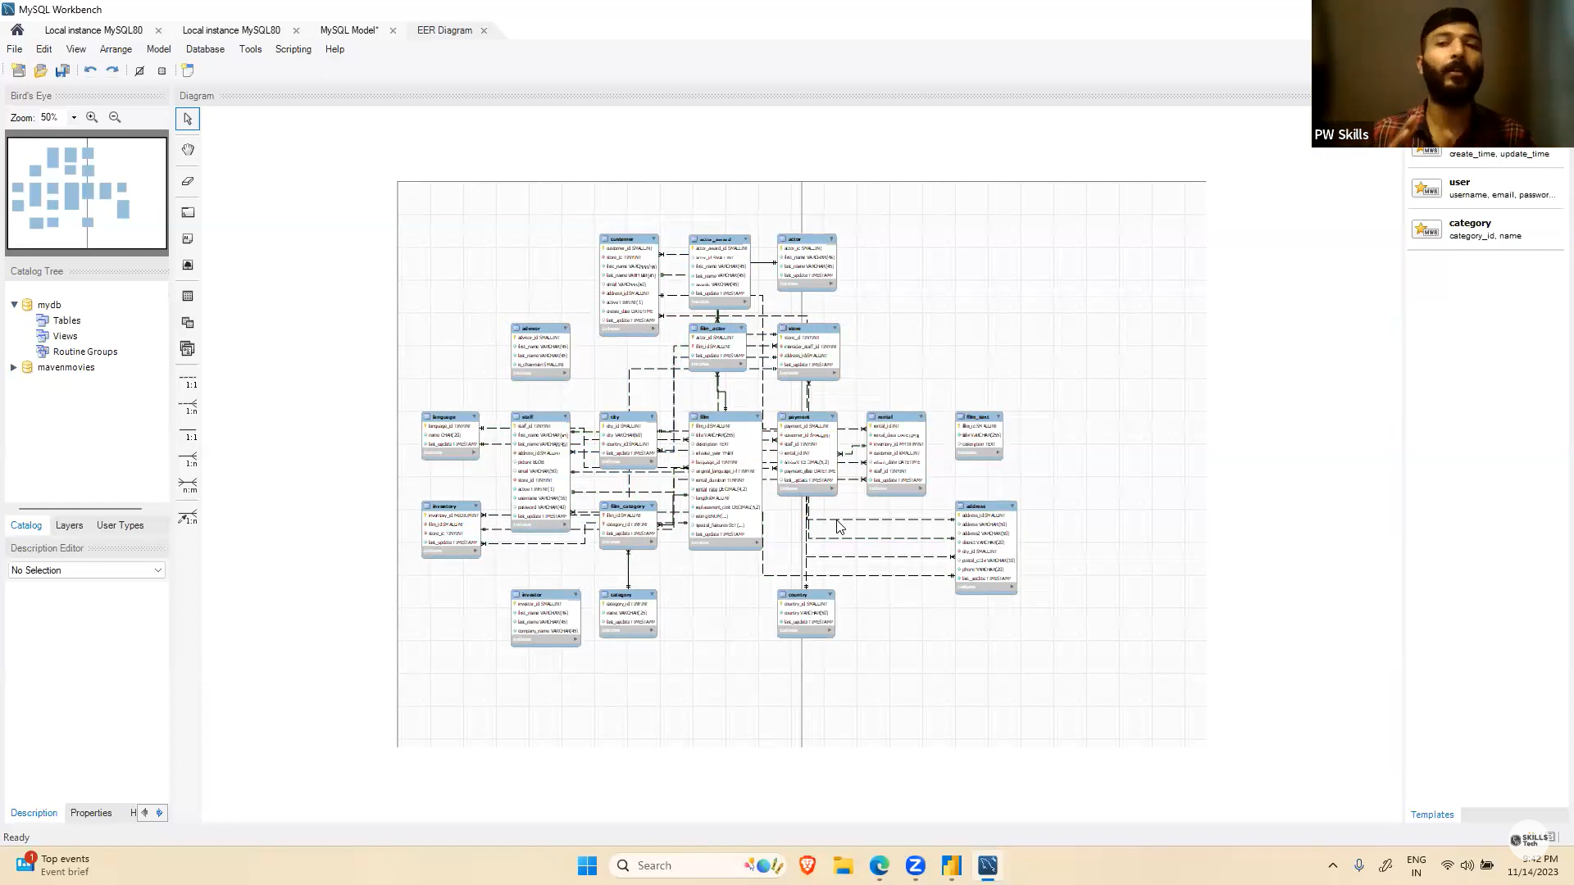
* 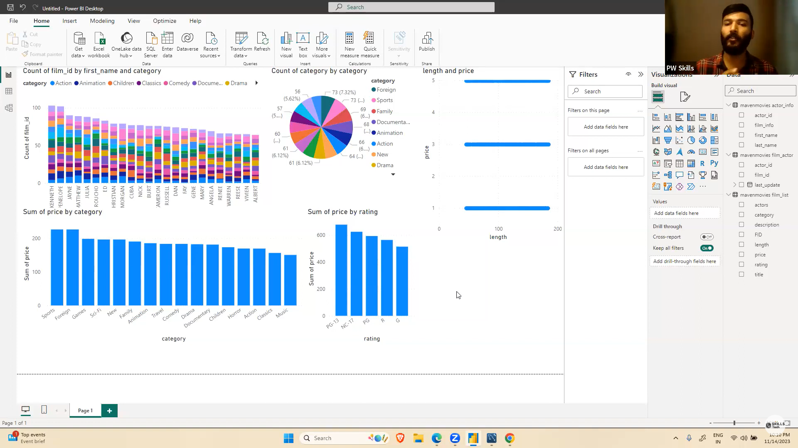

Lecture 08

* We have setup Microsoft sql workbench.
* We imported data through it.
* Analysed and setup relationship between tables.

Lecture 10

* Data cleaning, chart preparation.
* PowerBi github download data and chart

Lecture 11

* Did more analysis and better visualization